12. Applications of Pharmacokinetic Principles
The time course of drug concentration in the body after its administration can be defined by a number of pharmacokinetic parameters. Often, the information gained about the pharmacokinetics of one drug helps in anticipating the pharmacokinetics of another. The knowledge of pharmacokinetic behaviour of a drug coupled with important pharmacodynamic parameters like therapeutic index can be put to several applications:
- Design and development of new drugs with greatly improved therapeutic effectiveness and fewer or no toxic effects
- Design and development of an optimum formulation for better use of the drug
- Design and development of controlled/targeted release formulation
- Design an appropriate multiple dosage regimen
- Select the appropriate route for drug administration
- Select the right drug for a particular illness
- Predict and explain drug-food and drug-drug interactions
- Therapeutic drug monitoring in individual patients
- Dosage adjustment in situations of altered physiology and drug interactions.
The applications of pharmacokinetic principles are mainly aimed at achieving the therapeutic objective. The therapeutic objective is often control or cure of the condition in shortest possible time with minimum side effects by the use of least amount of drug. New drug development or chemical modification is frequently done to improve pharmacokinetic properties and increase efficacy. Drug product design is aimed at optimising bioavailability or better control/cure of illness through controlled- or targeted-release. Proper choice of route of administration is necessary to ensure that the drug moves to the site of action at a sufficiently rapid rate and amount. Selection of a suitable drug is based on achieving optimal therapy by balancing the desirable and undesirable effects. Co-administration of several drugs to a patient may lead to changes in the pharmacokinetic profile of a drug which is indicative of interactions between drugs. Such an understanding of interaction makes possible more rational use of drugs that have to be co-administered.
Clinically, the two most important applications of pharmacokinetic principles are:
- Design of an optimal dosage regimen, and
- Clinical management of individual patient and therapeutic drug monitoring.
Such applications permit the physician to use certain drugs more safely and sensibly.
DESIGN OF DOSAGE REGIMENS
Dosage regimen is defined as the manner in which a drug is taken. For some drugs like analgesics, hypnotics, antiemetics, etc., a single dose may provide effective treatment. However, the duration of most illnesses is longer than the therapeutic effect produced by a single dose. In such cases, drugs are required to be taken on a repetitive basis over a period of time depending upon the nature of illness. Thus, for successful therapy, design of an optimal multiple dosage regimen is necessary. An optimal multiple dosage regimen is the one in which the drug is administered in suitable doses (by a suitable route), with sufficient frequency that ensures maintenance of plasma concentration within the therapeutic window (without excessive fluctuations and drug accumulation) for the entire duration of therapy. For some drugs like antibiotics, a minimum effective concentration should be maintained at all times and for drugs with narrow therapeutic indices like phenytoin, attempt should be made not to exceed toxic concentration.

Approaches to Design of Dosage Regimen
The various approaches employed in designing a dosage regimen are –
- Empirical Dosage Regimen – is designed by the physician based on empirical clinical data, personal experience and clinical observations. This approach is, however, not very accurate.
- Individualized Dosage Regimen – is the most accurate approach and is based on the pharmacokinetics of drug in the individual patient. The approach is suitable for hospitalised patients but is quite expensive.
- Dosage Regimen on Population Averages – This is the most often used approach. The method is based on one of the two models –
  - Fixed model – here, population average pharmacokinetic parameters are used directly to calculate the dosage regimen.
  - Adaptive model – is based on both population average pharmacokinetic parameters of the drug as well as patient variables such as weight, age, sex, body surface area and known patient pathophysiology such as renal disease.
In designing a dosage regimen based on population averages —
- It is assumed that all pharmacokinetic parameters of the drug remain constant during the course of therapy once a dosage regimen is established. The same becomes invalid if any change is observed.
- The calculations are based on open one-compartment model which can also be applied to two compartment model if β is used instead of KE, and Vd,ss instead of Vd while calculating the regimen.
Irrespective of the route of administration and complexity of pharmacokinetic equations, the two major parameters that can be adjusted in developing a dosage regimen are —
- The dose size — the quantity of drug administered each time, and
- The dosing frequency — the time interval between doses.
Both parameters govern the amount of drug in the body at any given time.
Dose Size
The magnitude of both therapeutic and toxic responses depends upon dose size. Dose size calculation also requires the knowledge of amount of drug absorbed after administration of each dose. Greater the dose size, greater the fluctuations between Css,max and Css,min during each dosing interval and greater the chances of toxicity (Fig. 12.1). For drugs administered chronically, dose size calculation is based on average steady state blood levels and is computed from equation 12.8.
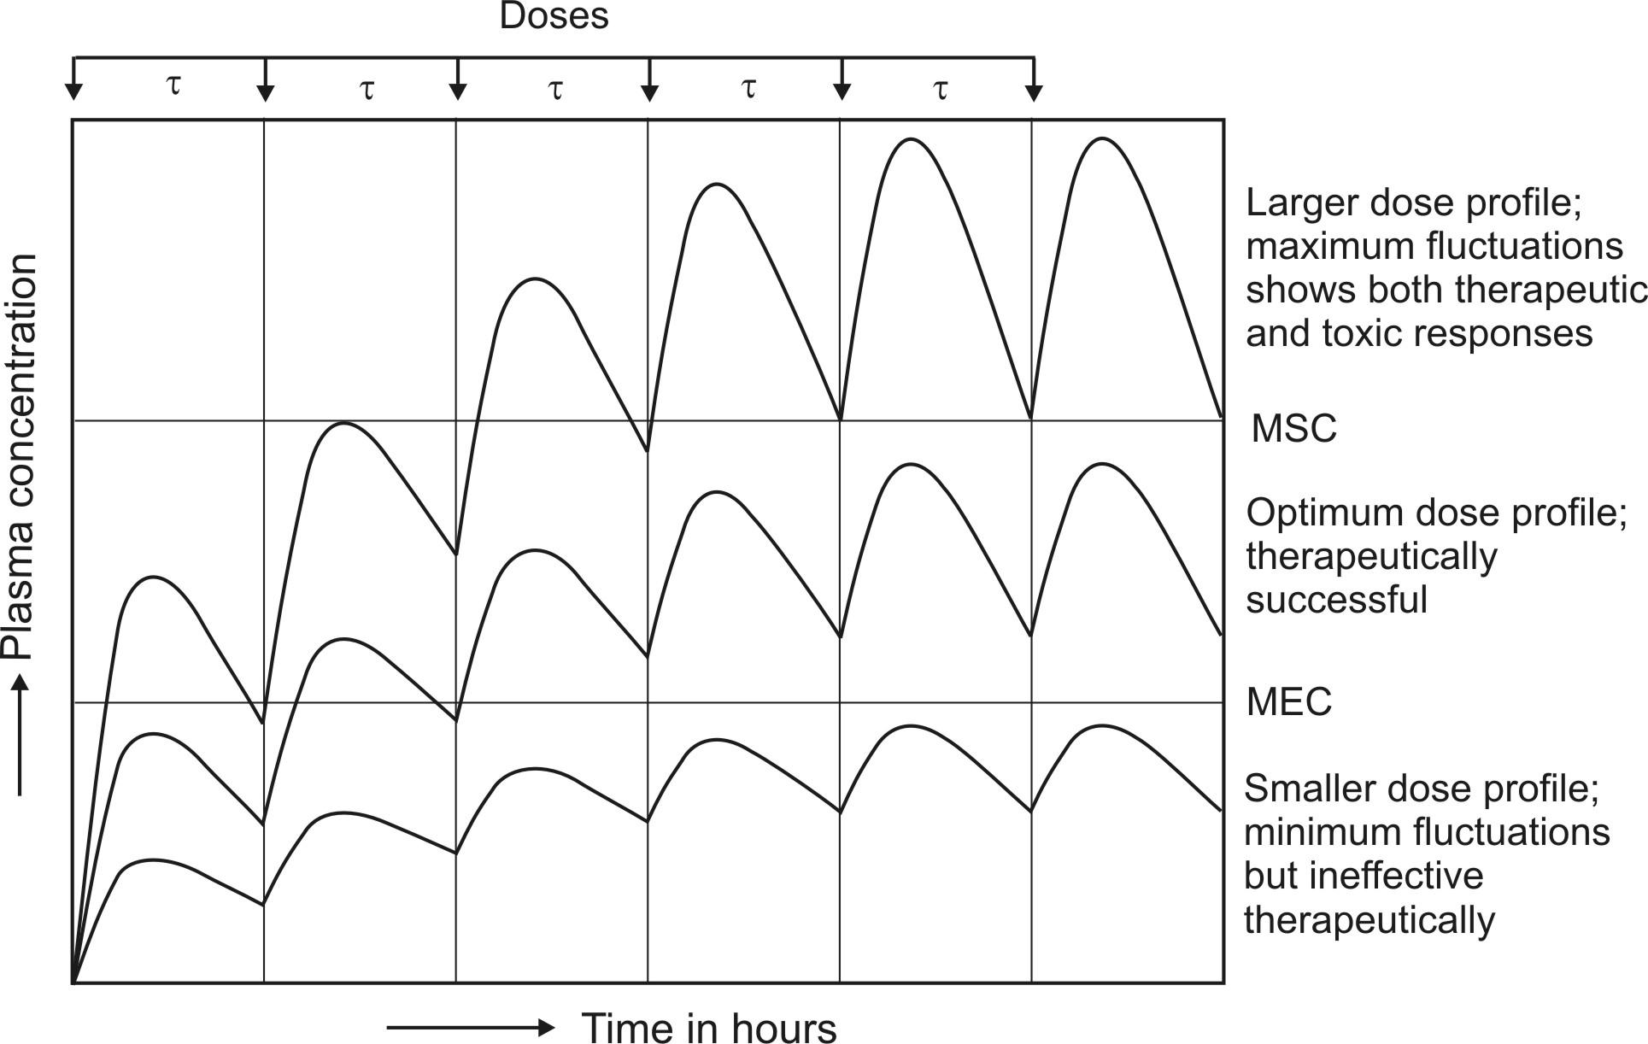
Fig. 12.1 Schematic representation of influence of dose size on plasma concentration-time profile after oral administration of a drug at fixed intervals of time.
Dosing Frequency
The dose interval (inverse of dosing frequency) is calculated on the basis of half-life of the drug. If the interval is increased and the dose is unchanged, Cmax, Cmin and Cav decrease but the ratio Cmax/Cmin increases. Opposite is observed when dosing interval is reduced or dosing frequency increased. It also results in greater drug accumulation in the body and toxicity (Fig. 12.2).
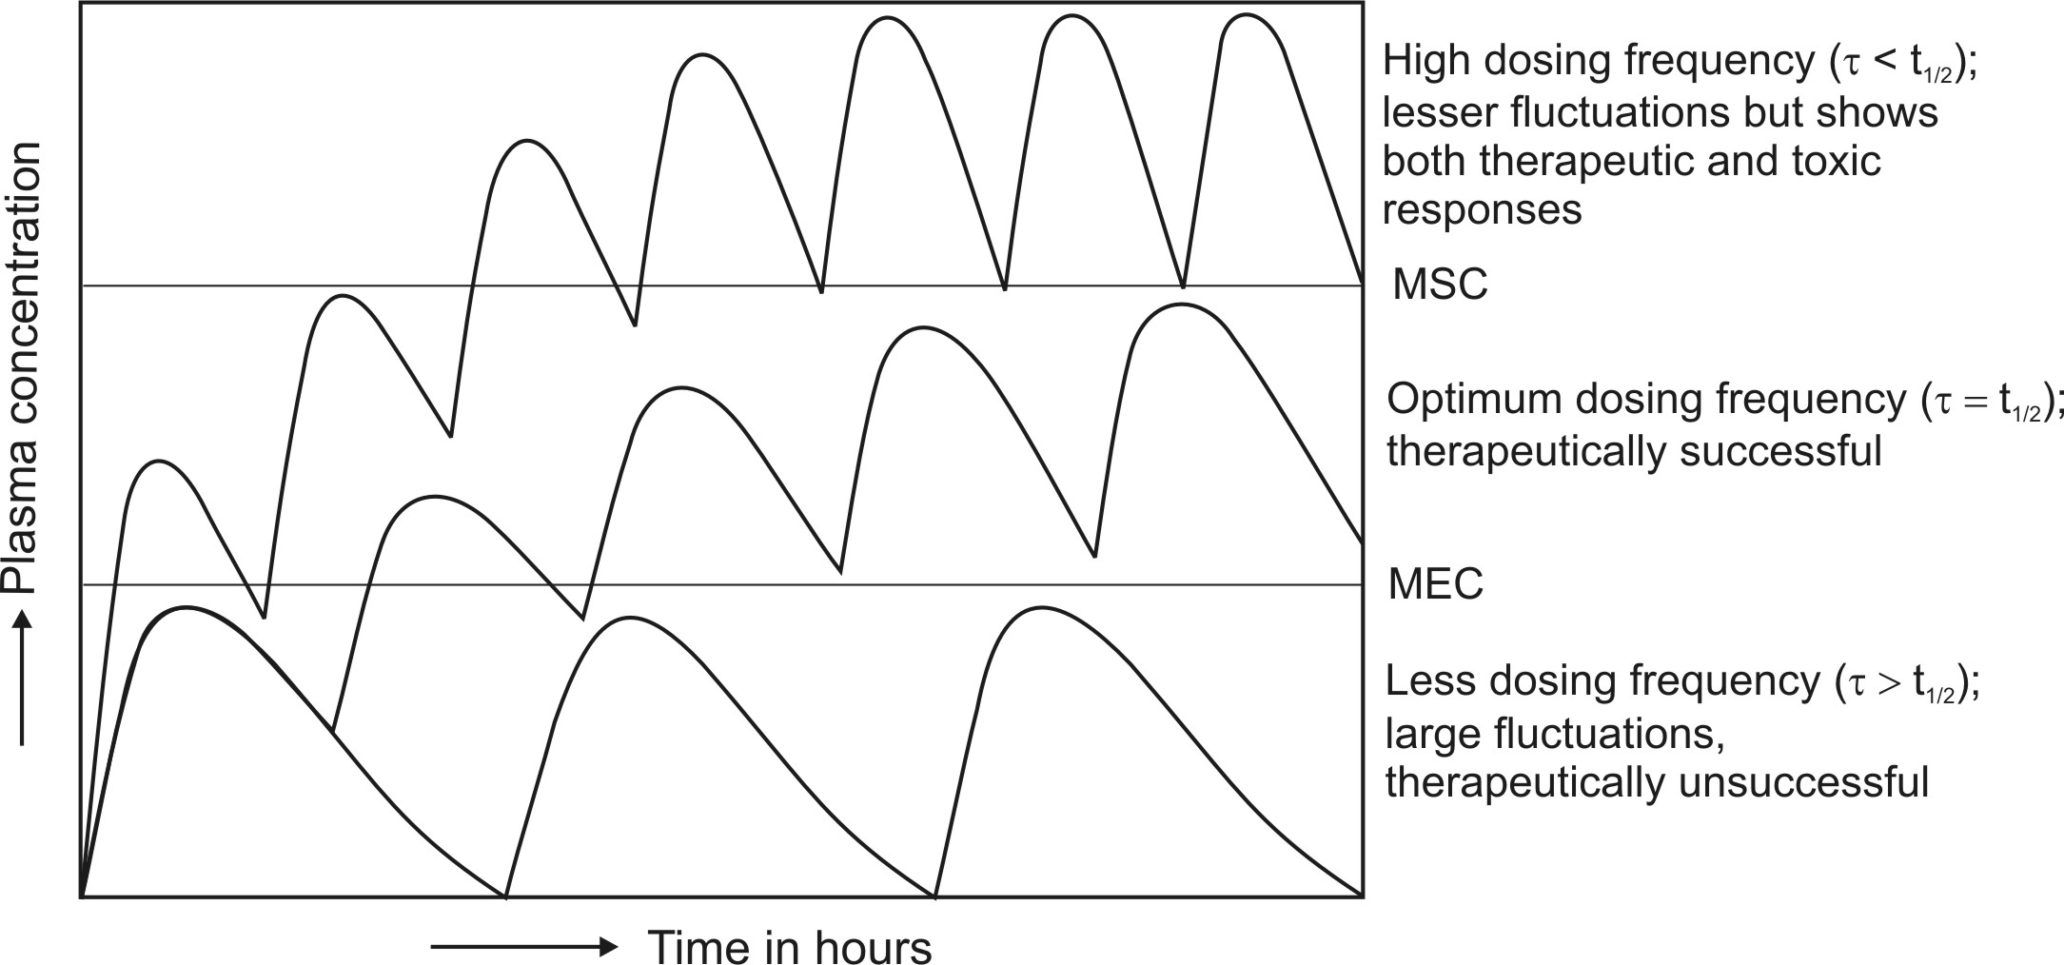
Fig. 12.2 Schematic representation of the influence of dosing frequency on plasma concentration-time profile obtained after oral administration of fixed doses of a drug.
A proper balance between both dose size and dosing frequency is often desired to attain steady-state concentration with minimum fluctuations and to ensure therapeutic efficacy and safety. The same cannot be obtained by giving larger doses less frequently. However, administering smaller doses more frequently results in smaller fluctuations.
Generally speaking, every subsequent dose should be administered at an interval equal to half-life of the drug. A rule of thumb is that –
- For drugs with wide therapeutic index such as penicillin, larger doses may be administered at relatively longer intervals (more than the half-life of drug) without any toxicity problem
- For drugs with narrow therapeutic index such as digoxin, small doses at frequent intervals (usually less than the half-life of the drug) is better to obtain a profile with least fluctuations which is similar to that observed with constant rate infusion or controlled-release system.
Drug Accumulation During Multiple Dosing
Consider the amount of drug in the body-time profile shown in Fig. 12.3. obtained after i.v. multiple dosing with dosing interval equal to one t½.
After the administration of first dose Xo at τ = 0, the amount of drug in the body will be X = 1Xo. At the next dosing interval when X = ½Xo, the amount of drug remaining in the body, administration of the next i.v. dose raises the body content to X = Xo + ½Xo i.e. drug accumulation occurs in the body. Thus, accumulation occurs because drug from previous doses has not been removed completely. As the amount of drug in the body rises gradually due to accumulation, the rate of elimination also rises proportionally until a steady-state or plateau is reached when the rate of drug entry into the body equals the rate of exit. The maximum and minimum values of X i.e. Xss,max and Xss,min approach respective asymptotes at plateau. It is interesting to note that at plateau, Xss,min = 1Xo and Xss,max = 2Xo i.e. Xss,min equals the amount of drug in the body after the first dose and Xss,max equals twice the first dose. Also (Xss,max – Xss,min) = Xo and Xss,max/Xss,min = 2. All this applies only when τ = t½ and drug is administered intravenously. When τ < t½, the degree of accumulation is greater and vice-versa.
Thus, the extent to which a drug accumulates in the body during multiple dosing is independent of dose size, and is a function of –
- Dosing interval, and
- Elimination half-life.
The extent to which a drug will accumulate with any dosing interval in a patient can be derived from information obtained with a single dose and is given by accumulation index Rac as:
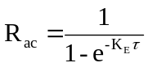 | (12.1)

Fig.12.3 Accumulation of drug in the body during multiple dose regimen of i.v. bolus with dosing interval equal to one half-life of the drug. Approximately 5 half-lives are required for attainment of steady-state.
Time to Reach Steady-State During Multiple Dosing
The time required to reach steady-state depends primarily upon the half-life of the drug. Provided Ka >> KE, the plateau is reached in approximately 5 half-lives. This is called as plateau principle. It also means that the rate at which the multiple dose steady-state is reached is determined only by KE. The time taken to reach steady-state is independent of dose size, dosing interval and number of doses.
Maximum and Minimum Concentration During Multiple Dosing
If n is the number of doses administered, the Cmax and Cmin obtained on multiple dosing after the nth dose is given as:
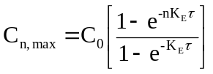 | (12.2)
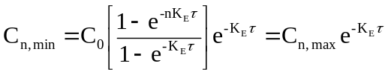 | (12.3)
The maximum and minimum concentration of drug in plasma at steady-state are found by following equations:
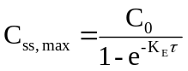 | (12.4)
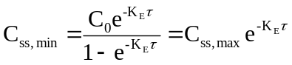 | (12.5)
where Co = concentration that would be attained from instantaneous absorption and distribution (obtained by extrapolation of elimination curve to time zero). Equations 12.2 to 12.5 can also be written in terms of amount of drug in the body. Fraction of dose absorbed, F, should be taken into account in such equations.
Fluctuation is defined as the ratio Cmax/Cmin. Greater the ratio, greater the fluctuation. Like accumulation, it depends upon dosing frequency and half-life of the drug. It also depends upon the rate of absorption. The greatest fluctuation is observed when the drug is given as i.v. bolus. Fluctuations are small when the drug is given extravascularly because of continuous absorption.
Average Concentration and Body Content on Multiple Dosing to Steady-State
The average drug concentration at steady-state Css,av is a function of –
- The maintenance dose Xo,
- The fraction of dose absorbed F,
- The dosing interval τ, and
- Clearance ClT (or Vd and KE or t½) of the drug.
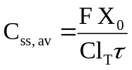 | (12.6)
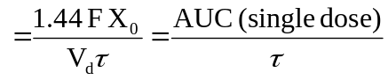 | (12.7)
where the coefficient 1.44 is the reciprocal of 0.693 in equation 12.7. AUC is the area under the curve following a single maintenance dose. Equation 12.7 can be used to calculate maintenance dose of a drug to achieve a desired concentration. Since X = Vd C, the body content at steady-state is given as:
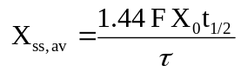 | (12.8)
These average values are not arithmetic mean of Css,max and Css,min since the plasma drug concentration declines exponentially.
Loading and Maintenance Doses
A drug does not show therapeutic activity unless it reaches the desired steady-state. It takes about 5 half-lives to attain it and therefore the time taken will be too long if the drug has a long half-life. Plateau can be reached immediately by administering a dose that gives the desired steady-state instantaneously before the commencement of maintenance doses Xo. Such an initial or first dose intended to be therapeutic is called as priming dose or loading dose Xo,L. A simple equation for calculating loading dose is:
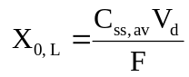 | (12.9)
After e.v. administration, Cmax is always smaller than that after i.v. administration and hence loading dose is proportionally smaller. For drugs having low therapeutic indices, the loading dose may be divided into smaller doses to be given at various intervals before the first maintenance dose. When Vd is not known, loading dose may be calculated by the following equation:
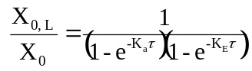 | (12.10)
The above equation applies when Ka >> KE and drug is distributed rapidly. When the drug is given i.v. or when absorption is extremely rapid, the absorption phase is neglected and the above equation reduces to accumulation index:
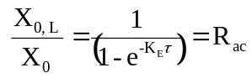 | (12.11)
The ratio of loading dose to maintenance dose Xo,L/Xo is called as dose ratio. As a rule, when τ = t½, dose ratio should be equal to 2.0 but must be smaller than 2.0 when τ > t½ and greater when τ < t½. Fig. 12.4. shows that if loading dose is not optimum, either too low or too high, the steady-state is attained within approximately 5 half-lives in a manner similar to when no loading dose is given.
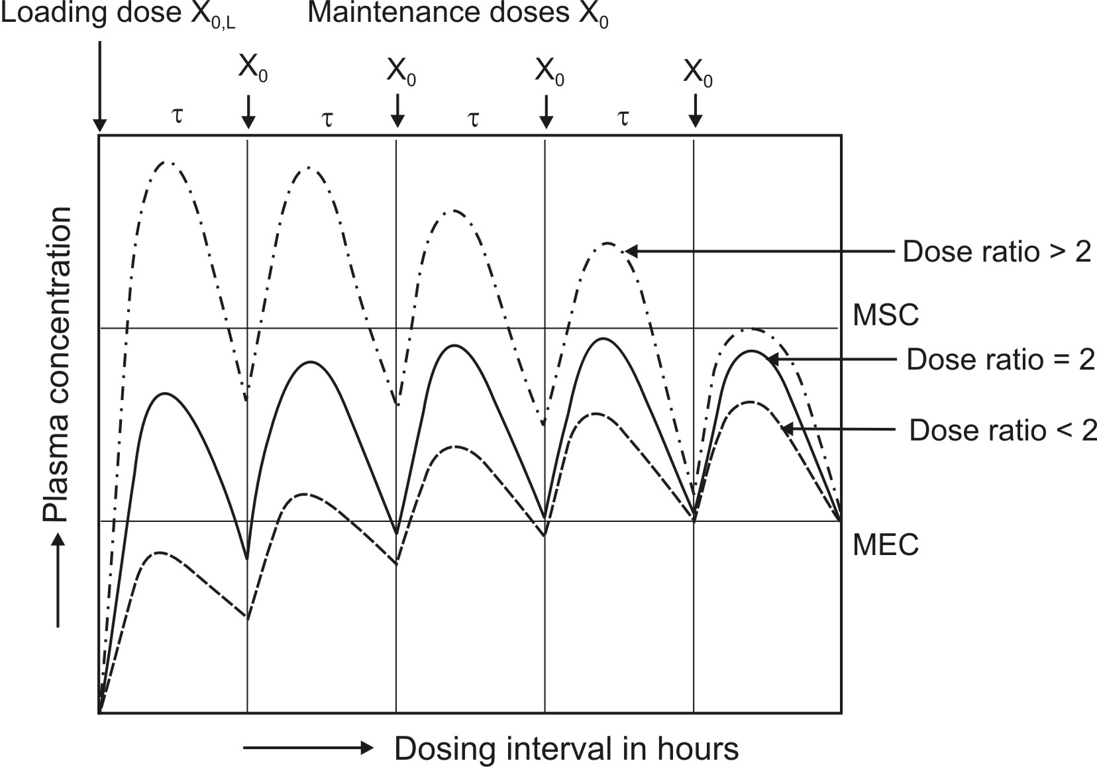
Fig. 12.4 Schematic representation of plasma concentration-time profiles that result when dose ratio is greater than 2.0, equal to 2.0 and smaller than 2.0.
The foregoing discussion and the equations expressed until now apply only to drugs that follow one-compartment kinetics with first-order disposition. Equations will be complex for multicompartment models.
Maintenance of Drug within the Therapeutic Range
The ease or difficulty in maintaining drug concentration within the therapeutic window depends upon —
1. The therapeutic index of the drug
2. The half-life of the drug
3. Convenience of dosing.
It is extremely difficult to maintain such a level for a drug with short half-life (less than 3 hours) and narrow therapeutic index e.g. heparin, since the dosing frequency has to be essentially less than t½. However, drugs such as penicillin (t½ = 0.9 hours) with high therapeutic index may be given less frequently (every 4 to 6 hours) but the maintenance dose has to be larger so that the plasma concentration persists above the minimum inhibitory level. A drug with intermediate t½ (3 to 8 hours) may be given at intervals τ ≤ t½ if therapeutic index is low and those with high indices can be given at intervals between 1 to 3 half-lives. Drugs with half-lives greater than 8 hours are more convenient to dose. Such drugs are usually administered once every half-life. Steady-state in such cases can be attained rapidly by administering a loading dose. For drugs with very long half-lives (above 24 hours) e.g. amlodipine, once daily dose is very convenient.
Design of Dosage Regimen from Plasma Concentrations
If the therapeutic range, apparent Vd and clearance or half-life of a drug is known, then dosage regimen can be designed to maintain drug concentration within the specified therapeutic range. The latter is defined by lower limit (Clower) and an upper limit (Cupper). The maximum dosing interval, which ideally depends upon the therapeutic index (can be defined as a ratio of Cupper to Clower) and elimination half-life of the drug, can be expressed by equation 12.12, a modification of equation 12.5.
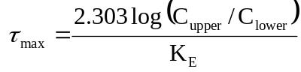 | (12.12)
Since KE = 0.693/t½, the above equation can also be written as:
 | (12.13)
Understandably, the dosing interval selected is always smaller than τmax. The maximum maintenance dose Xo,max that can be given every τmax is expressed as:
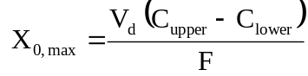 | (12.14)
After a convenient dosing interval τ, smaller than τmax has been selected, the maintenance dose is given as:
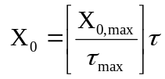 | (12.15)
Administration of Xo every τ produces an average steady-state concentration defined by equation 12.7. The value of Css,av can also be calculated from the therapeutic range according to equation 12.16.
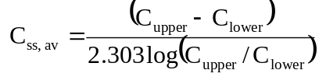 | (12.16)
INDIVIDUALIZATION
Because of reasonable homogeneity in humans, the dosage regimens are calculated on population basis. However, same dose of a drug may produce large differences in pharmacological response in different individuals. This is called as intersubject variability. In other words, it means that the dose required to produce a certain response varies from individual to individual. Rational drug therapy requires individualization of dosage regimen to fit a particular patient's needs. This requires knowledge of pharmacokinetics of drugs. The application of pharmacokinetic principles in the dosage regimen design for the safe and effective management of illness in individual patient is called as clinical pharmacokinetics.
The two sources of variability in drug responses are:
- Pharmacokinetic variability which is due to differences in drug concentration at the site of action (as reflected from plasma drug concentration) because of interindividual differences in drug absorption, distribution, metabolism and excretion.
- Pharmacodynamic variability which is attributed to differences in effect produced by a given drug concentration.
The major cause for variations is pharmacokinetic variability. Differences in the plasma levels of a given drug in the same subject when given on different occasions is called as intrasubject variability. It is rarely encountered in comparison to interindividual variations. The differences in variability differ for different drugs. Some drugs show greater variability than the others. The major causes of intersubject pharmacokinetic variability are genetics, disease, age, body-weight and drug-drug interactions. Less important causes are pharmaceutical formulation, route of administration, environmental factors and patient noncompliance.
The main objective of individualization is aimed at optimising the dosage regimen. An inadequate therapeutic response calls for a higher dosage whereas drug related toxicity calls for a reduction in dosage. Thus, in order to aid individualization, a drug must be made available in dosage forms of different dose strengths. The number of dose strengths in which a drug should be made available depends upon 2 major factors—
  - The therapeutic index of the drug, and
  - The degree of inter-subject variability.
Smaller the therapeutic index and greater the variability, more the number of dose strengths required.
Based on the assumption that all patients require the same plasma drug concentration range for therapeutic effectiveness, the steps involved in the individualization of dosage regimen are:
    - Estimation of pharmacokinetic parameters in individual patient and determining their deviation from the population values to evaluate the extent of variability. Greater the accountability of variations, better the chances of attaining the desired therapeutic objective.
    - Attributing the variability to some measurable characteristic such as hepatic or renal disease, age, weight, etc.
    - Designing the new dosage regimen from the collected data.
The design of new dosage regimen involves:
- Adjustment of dosage, or
- Adjustment of dosing interval, or
- Adjustment of both dosage and dosing interval.
Dosing of Drugs in Obese Patients
The apparent volume of distribution of a drug is greatly affected by changes in body weight since the latter is directly related to the volume of various body fluids. The ideal body weight (IBW) for men and women can be calculated from following formulae:
IBW (men) = 50 Kg ± 1 Kg/2.5 cm above or below 150 cm in height | (12.17)
IBW (women) = 45 Kg ± 1 Kg/2.5 cm above or below 150 cm in height | (12.18)
Any person whose body weight is more than 25% above the IBW is considered obese. In such patients, the lean-to-adipose tissue ratio is small because of greater proportion of body fat which alters the Vd of drugs. The ECF of adipose tissue is small in comparison to lean tissue in obese patients.
Following generalizations can be made regarding drug distribution and dose adjustment in obese patients:
- For drugs such as digoxin that do not significantly distribute in the excess body space, Vd do not change and hence dose to be administered should be calculated on IBW basis.
- For polar drugs such as antibiotics (gentamicin) which distribute in excess body space of obese patients to an extent less than that in lean tissues, the dose should be lesser on per Kg total body weight basis but more than that on IBW basis.
- In case of drugs such as caffeine, theophylline, lidocaine and lorazepam which distribute to the same extent in both lean and adipose tissues, the Vd is larger in obese patients but same on per Kg total body weight basis; hence, dose should be administered on total body weight basis.
- For drugs such a phenytoin, diazepam and thiopental which are lipid soluble and distribute more in adipose tissues, the Vd is larger per Kg body weight in obese patients and hence they require larger doses, more than that on total body weight basis.
Changes in dose based on alteration of Vd is also attributed to modification of clearance and half-life of the drug.
Dosing of Drugs in Neonates, Infants and Children
The usual dosage regimen calculated on population basis refers to that for adults. Neonates, infants and children require different dosages than adults because of differences in body surface area, TBW and ECF on per Kg body weight basis. The dose for such patients are calculated on the basis of their body surface area and not on body weight basis because the body surface area correlates better with dosage requirement, cardiac output, renal blood flow and glomerular filtration in children. A simple formula in comparison to DuBois and DuBois for computing surface area (SA) in square meters is Mosteller’s equation:
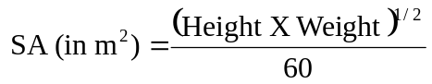 | (12.19)
Infants and children require larger mg/Kg doses than adults because:
- Their body surface area per Kg body weight is larger, and hence
- Larger volume of distribution (particularly TBW and ECF).
The child’s maintenance dose can be calculated from adult dose by using the following equation:
 | (12.20)
where 1.73 is surface area in m2 of an average 70 Kg adult. Since the surface area of a child is in proportion to the body weight according to equation 12.21,
SA (in m2) = Body Weight (in Kg)0.7 | (12.21)
The following relationship can also be written for child’s dose:
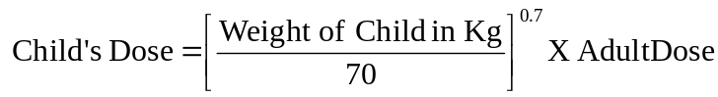 | (12.22)
As the TBW in neonates is 30% more than that in adults,
- The Vd for most water-soluble drugs is larger in infants, and
- The Vd for most lipid-soluble drugs is smaller.
Accordingly, the dose should be adjusted.
Dosing of Drugs in Elderly
Drug dose should be reduced in elderly patients because of a general decline in body function with age. The lean body mass decreases and body fat increases by almost 100% in elderly persons as compared to adults. Because of smaller volume of body water, higher peak alcohol levels are observed in elderly subjects than in young adults. Vd of a water-soluble drug may decrease and that of a lipid-soluble drug like diazepam increases with age. Age related changes in hepatic and renal function greatly alters the clearance of drugs. Because of progressive decrease in renal function, the dosage regimen of drugs that are predominantly excreted unchanged in urine should be reduced in elderly patients.
A general equation that allows calculation of maintenance dose for a patient of any age (except neonates and infants) when maintenance of same Css,av is desired is:
 | (12.23)
Dosing of Drugs in Hepatic Disease
Disease is a major source of variations in drug response. Both pharmacokinetics and pharmacodynamics of many drugs are altered by diseases other than the one which is being treated.
The influence of hepatic disorder on drug availability and disposition is unpredictable because of the multiple effects that liver disease produces—effects on drug metabolising enzymes, on drug binding and on hepatic blood flow. Hence, a correlation between altered drug pharmacokinetics and hepatic function is often difficult. For example, unlike excretion, there are numerous pathways by which a drug may be metabolised and each is affected to a different extent in hepatic disease. Generally speaking, drug dosage should be reduced in patients with hepatic dysfunction since clearance is reduced and availability is increased in such a situation.
Dosing of Drugs in Renal Disease
In patients with renal failure, the half-life of a drug is increased and its clearance drastically decreased if it is predominantly eliminated by way of excretion. Hence, dosage adjustment should take into account the renal function of the patient and the fraction of unchanged drug excreted in urine. One such method was discussed in chapter 6 on Excretion of Drugs.
There are two additional methods for dose adjustment in renal insufficiency if the Vd change is assumed to be negligible. These methods are based on maintaining the same average steady-state concentration during renal dysfunction as that achieved with the usual multiple dosage regimen and normal renal function. The adjustments are based on equations 12.6 and 12.7.
1. Dose adjustment based on total body clearance: Rewriting equation 12.6, the parameters to be adjusted in renal insufficiency are shown below:
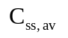 | = | F | X | 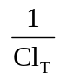 | X | 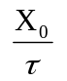
(12.6)
↑ |  | ↑ |  | ↑ |  | ↑
to be kept normalassumed constantdecreased due to disease needs adjustmentIf ClT', Xo' and τ' represent the values for the renal failure patient, then the equation for dose adjustment is given as:
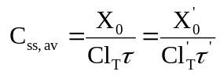 | (12.24)
Rearranging in terms of dose and dose interval to be adjusted, the equation is:
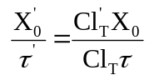 | (12.25)
From above equation, the regimen may be adjusted by reduction in dosage or increase in dosing interval or a combination of both.
2. Dose adjustment based on elimination rate constant or half-life: Rewriting equation 12.7, the parameters to be adjusted in renal insufficiency are:
 | = | 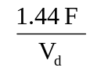 | X | 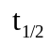 | X | 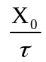
(12.7)
↑ |  | ↑ |  | ↑ |  | ↑
to be kept normalassumed constantdecreased due to disease needs adjustmentIf t½', Xo' and τ' represent the values for the renal failure patient, then:
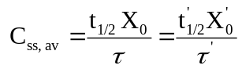 | (12.26)
Rearranging the above equation in terms of dose and dose interval to be adjusted, we get:
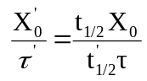 | (12.27)
Because of prolongation of half-life of a drug due to reduction in renal function, the time taken to achieve the desired plateau takes longer, the more severe the dysfunction. Hence, such patients sometimes need loading dose.
MONITORING DRUG THERAPY
Management of drug therapy in individual patient often requires evaluation of response of the patient to the recommended dosage regimen. This is known as monitoring of drug therapy. It is necessary to ensure that the therapeutic objective is being attained and failure to do so requires readjustment of dosage regimen.
Depending upon the drug and the disease to be treated, management of drug therapy in individual patient can be accomplished by:
- Monitoring therapeutic effects — therapeutic monitoring
- Monitoring pharmacological actions — pharmacodynamic monitoring
- Monitoring plasma drug concentration — pharmacokinetic monitoring.
Therapeutic Monitoring
In this approach, the management plan involves monitoring the incidence and intensity of both the desired therapeutic effects and the undesired adverse effects. A direct measure of the desired effect is considered as a therapeutic endpoint e.g. prevention of an anticipated attack of angina or shortening of duration of pain when attack occurs through the use of sublingual glyceryl trinitrate. In certain cases, definition of therapeutic endpoint may not be clear and onset of toxicity is used as a dosing guide i.e. dosage regimen is titrated to a toxic endpoint e.g. excessive dryness of mouth with atropine when used as an antispasmodic agent.
Pharmacodynamic Monitoring
In some instances, the pharmacological actions of a drug can be measured and used as a guide to therapeutic process. The response observed may or may not correlate exactly with the therapeutic effect e.g. blood glucose lowering with insulin, lowering of blood pressure with antihypertensives, enhancement of haemoglobin levels with haematinics, etc.
Pharmacokinetic Monitoring
This approach involves monitoring the plasma drug concentration within a target concentration range (called as target concentration strategy) and based on the principle that free drug at the site of action is in equilibrium with the drug in plasma. The strategy is particularly useful when:
- Therapeutic endpoints are difficult to define or are lacking e.g. control of seizures with phenytoin.
- The objective is to maintain the therapeutic effect in order to obtain optimum drug use.
- The probability of therapeutic failure is high as with drugs having low therapeutic indices, erratic absorption, pharmacokinetic variability or when the drug is used in multiple drug therapy.
Successful application of this approach requires complete knowledge of pharmacokinetic parameters of the drug, the situation in which these parameters are likely to be altered and the extent to which they could be altered, and a sensitive, specific and accurate analytical method for determination of drug concentration. Examples of drugs monitored by this method include digoxin, phenytoin, gentamicin, theophylline, etc. The strategy is very useful in individualizing therapy in patients with hepatic or renal impairment when dose adjustments are necessary.
QUESTIONS
- Enlist various applications of pharmacokinetic principles.
- What do you understand by therapeutic objective? What are the various ways of attaining it?
- Define optimal dosage regimen. What does it mean for a drug with narrow therapeutic index such as phenytoin and for drugs like antibiotics?
- What assumptions are made in the design of a dosage regimen?
- Name the two parameters that are generally adjusted in developing a dosage regimen.
- It is safer to administer a drug with a narrow therapeutic index in small doses at frequent intervals. Explain.
- On what parameters does extent of drug accumulation on multiple dosing depend? Does dose size have a bearing on it?
- State the plateau principle. Which parameters govern attainment of steady-state?
- Define fluctuation of plasma level. Why are fluctuations smaller when the drug is given e.v. whereas larger when administered as multiple i.v. boluses?
- The Css,av is not an arithmetic mean of Css,max and Css,min. Why?
- Define dose ratio. Why is it always smaller for extravascularly administered drugs in comparison to those given intravenously?
- On what factors do maintenance of drug concentration within the therapeutic range depend?
- How is dosing interval determined on the basis of half-life and therapeutic index of the drug?
- What are the two major sources of variability in drug response?
- Quote some of the more important causes of intersubject variability in drug response.
- Enlist the steps involved in individualization of dosage regimen.
- How does obesity influence Vd of a drug and hence its dose size?
- The dose for neonates, infants and children should be calculated on body surface area basis rather than on the basis of body weight. Explain.
- Why do neonates, infants and children require larger mg/Kg body weight doses than adults?
- Give possible reasons for reduction in dose of a drug in elderly patients.
- Unlike renal function, why is it difficult to establish a correlation between hepatic dysfunction and altered drug pharmacokinetics?
- Why does it take longer to attain the steady-state in a renal failure patient in comparison to a patient with normal renal function?
- What do you understand by monitoring of drug therapy? When does it become necessary?
- What are the various ways of monitoring drug therapy in individual patient?
- What parameters are monitored in therapeutic drug monitoring?
- On what principle is pharmacokinetic drug monitoring based? When does such a strategy become useful?
- What criteria are necessary for successful pharmacokinetic drug monitoring?
- The loading dose is calculated on the basis of apparent Vd of a drug whereas maintenance dose is determined from its t½. Explain.
- Atenolol is to be administered orally to a 50 Kg patient suffering from hypertension. The typical parameters of the drug on population basis are:
F | Vd | ClT | Therapeutic Range
0.4 | 1.23 litre/Kg | 118.4 ml/min | 0.2 to 1.3 mcg/ml
Design a dosage regimen to attain and maintain the plasma concentration within the therapeutic range. Assume rapid absorption.
Answer: Css,av = 0.588 mcg/ml, τmax = 16.21 hours, Xo,max = 169.12mg. It is convenient to administer the drug once every 12 hours. Therefore, Xo in such a situation should be 125.3 mg. Loading dose is 90.4 mg.
- Diltiazem is administered in a dose of 60 mg q.i.d. The oral availability of the drug is 50%, Vd is 30 litres and elimination half-life is 4 hours.
a. Determine the maximum and minimum amounts of drug in the body after 4 doses.
Answer: X4,max = 45.7 mg and X4,min = 16.16 mg.
b. Calculate the maximum and minimum amounts of drug in the body at steady-state.
Answer: Xss,max = 46.4 mg and Xss,min = 16.4 mg.
c. What is the accumulation index?
Answer: Rac = 1.55.
d. What is the average amount of drug in the body at steady-state?
Answer: Xss,av = 28.8 mg.
e. If the desired Css,av is 0.099 mcg/ml, is there any need to administer the loading dose?
- Netilmicin is to be administered to a 70 Kg patient at a rate of 2 mg/Kg every 12 hours by multiple i.m. injections. The drug has a half-life of 2.2 hours and Vd of 0.2 l/Kg.
a. Determine Css,max, Css,min and Css,av.
Answer: Css,max = 10.2 mcg/ml, Css,min = 0.23 mcg/ml and Css,av = 2.64 mcg/ml.
b. If the t½ increases to 5 hours in renal insufficiency, what should be the new dose or the new dosing interval?
Answer: New dose (τ unchanged) = 0.88 mg/Kg, new dosing interval (dose unchanged) = 27.3 hours.
c. If the drug is to be injected once every 24 hours, in renal insufficiency, what should be the new dose?
Answer: 1.76 mg/Kg.
d. If netilmicin is to be given to a child weighing 12 Kg with normal renal function, what should be the dose?
Answer: 3.4 mg/Kg.
e. If the same drug is to be administered to an elderly patient of 85 years and 55 Kg body weight, determine the dose.
Answer: 1.4 mg/Kg.
- Procainamide is to be administered to a 65 Kg arrhythmic patient as 500 mg tablets every 4 hours. The drug has a half-life of 3 hours, Vd of 2 litre/Kg and oral availability of 0.85.
a. Calculate the steady-state concentration of procainamide.
Answer: Css,av = 3.53 mcg/ml.
b. Determine whether the patient is adequately dosed (therapeutic range is 4 to 12 mcg/ml)
c. What changes would you recommend in the dosage regimen?
Answer: Desired Css,av = 7.3 mcg/ml which can be attained by increasing the maintenance dose to 1000 mg or 2 tablets every 4 hours.
- Two aminoglycoside antibiotics along with some of their parameters are listed in the table below:
Drug | t½ | Fe | TI | Route | Normal dose | Normal interval
Streptomycin | 3 hrs | 0.5 | 1.25 | i.m. | 7.5 mg/Kg | 12 hrs
Gentamicin | 2 hrs | 0.9 | 20.00 | i.m. | 1.0 mg/Kg | 8 hrs
These drugs are to be administered to a uremic patient. Suggest the changes that should be made in the dosage regimen—keeping the dose constant and prolonging the interval or decreasing the dose and maintaining the dosage interval or changing both. Discuss the advantages and disadvantages of each approach.

